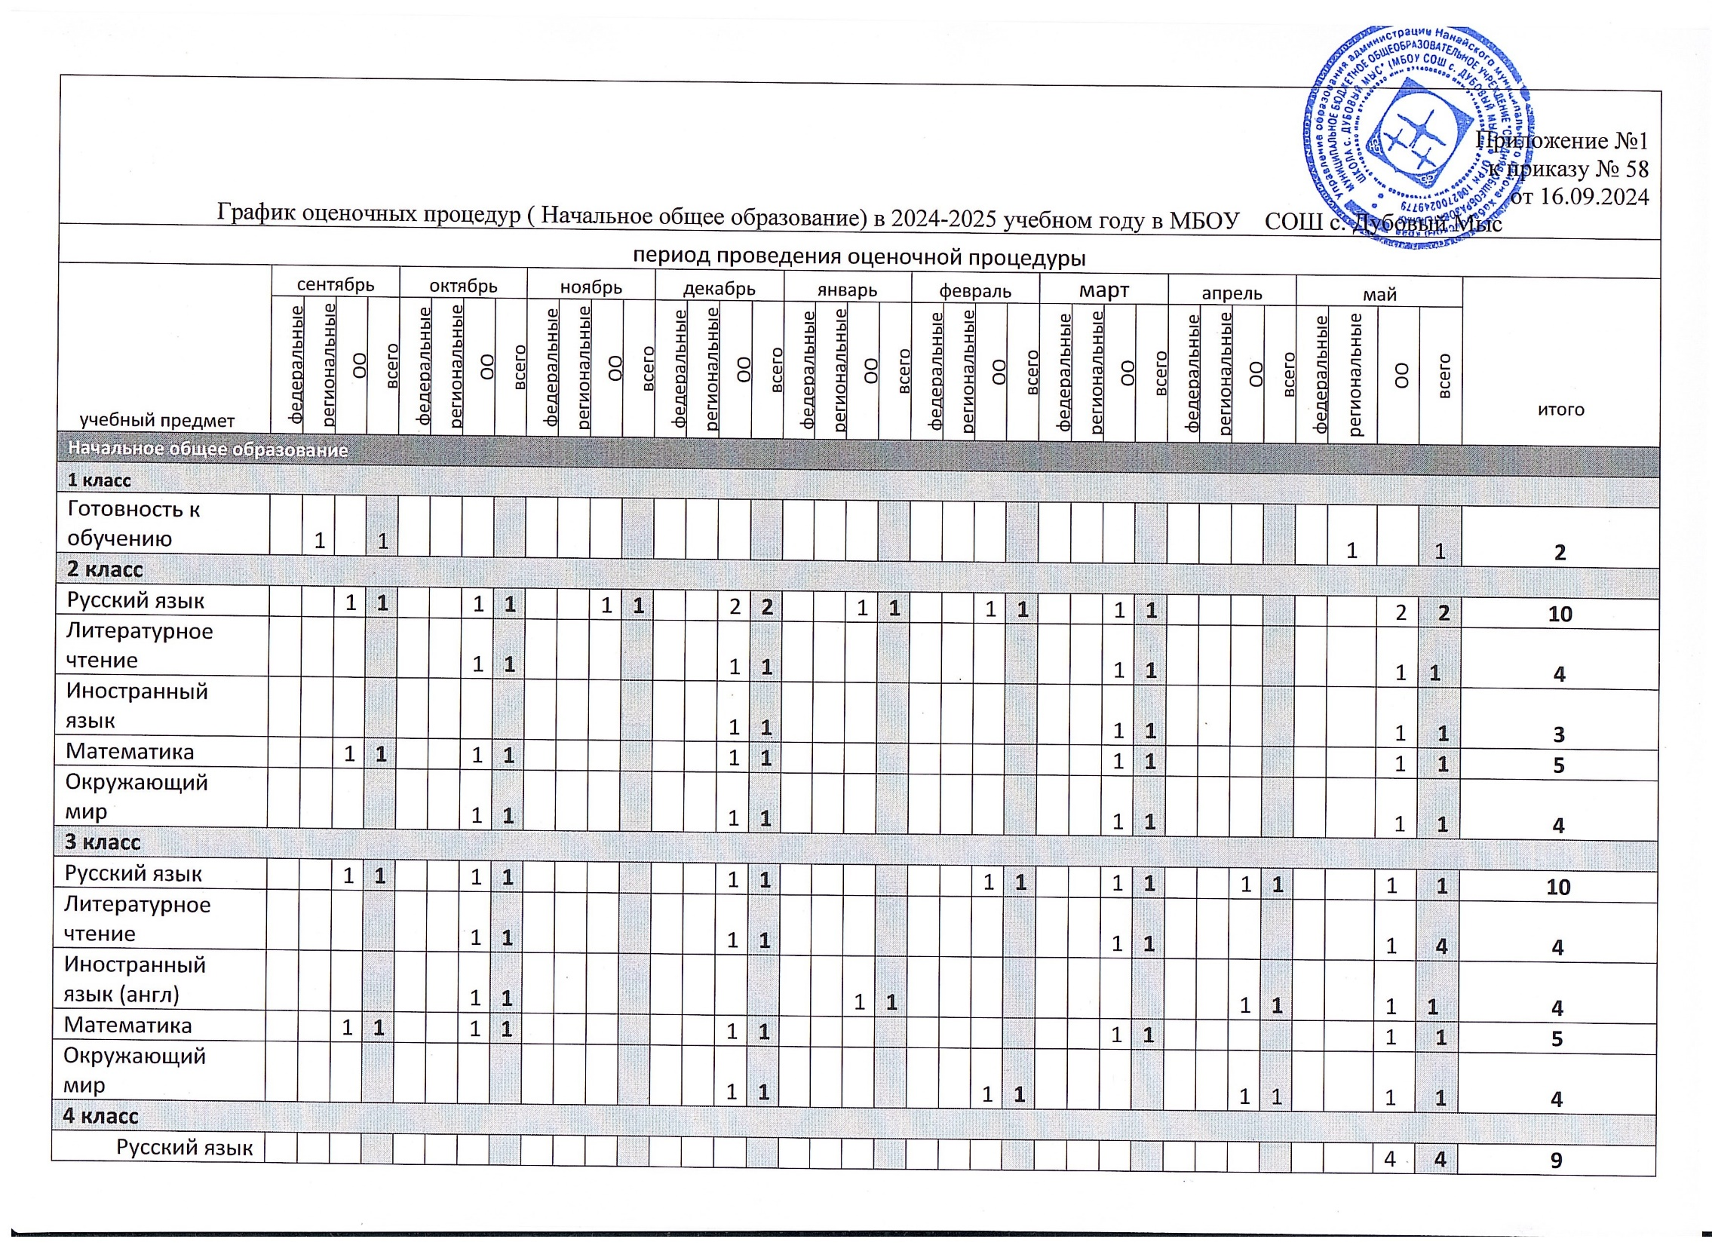

|  |  |  |  |  |  |  |  |  |  |  |  |  |  |  |  |  |  |  |  |  |  |  |  |  |  |  |  |  |  |  |  |  |  |  |  |  |  |
| --- | --- | --- | --- | --- | --- | --- | --- | --- | --- | --- | --- | --- | --- | --- | --- | --- | --- | --- | --- | --- | --- | --- | --- | --- | --- | --- | --- | --- | --- | --- | --- | --- | --- | --- | --- | --- | --- |
| Литературное чтение |  |  | 1 | **1** |  |  | 1 | **1** |  |  | 1 | **1** |  |  |  |  |  |  | 1 | **1** |  |  | 1 | **1** |  |  | 1 | **1** |  |  | 1 | **1** |  |  | 1 | **1** | **8** |
| Иностранный язык (англ) |  |  |  |  |  |  | 1 | **1** |  |  |  |  |  |  | 1 | **1** |  |  |  |  |  |  |  |  |  |  | 1 | **1** |  |  |  |  |  |  | 1 | **1** | **4** |
| Математика |  |  |  |  |  |  | 1 | **1** |  |  |  |  |  |  | 1 | **1** |  |  |  |  |  |  | 1 | **1** |  |  |  |  |  |  | 1 | **1** |  |  | 1 | **1** | **5** |
| Окружающий мир |  |  |  |  |  |  |  |  |  |  |  |  |  |  |  |  |  |  | 2 | **2** |  |  |  |  |  |  |  |  |  |  |  |  |  |  | 2 | **2** | **4** |