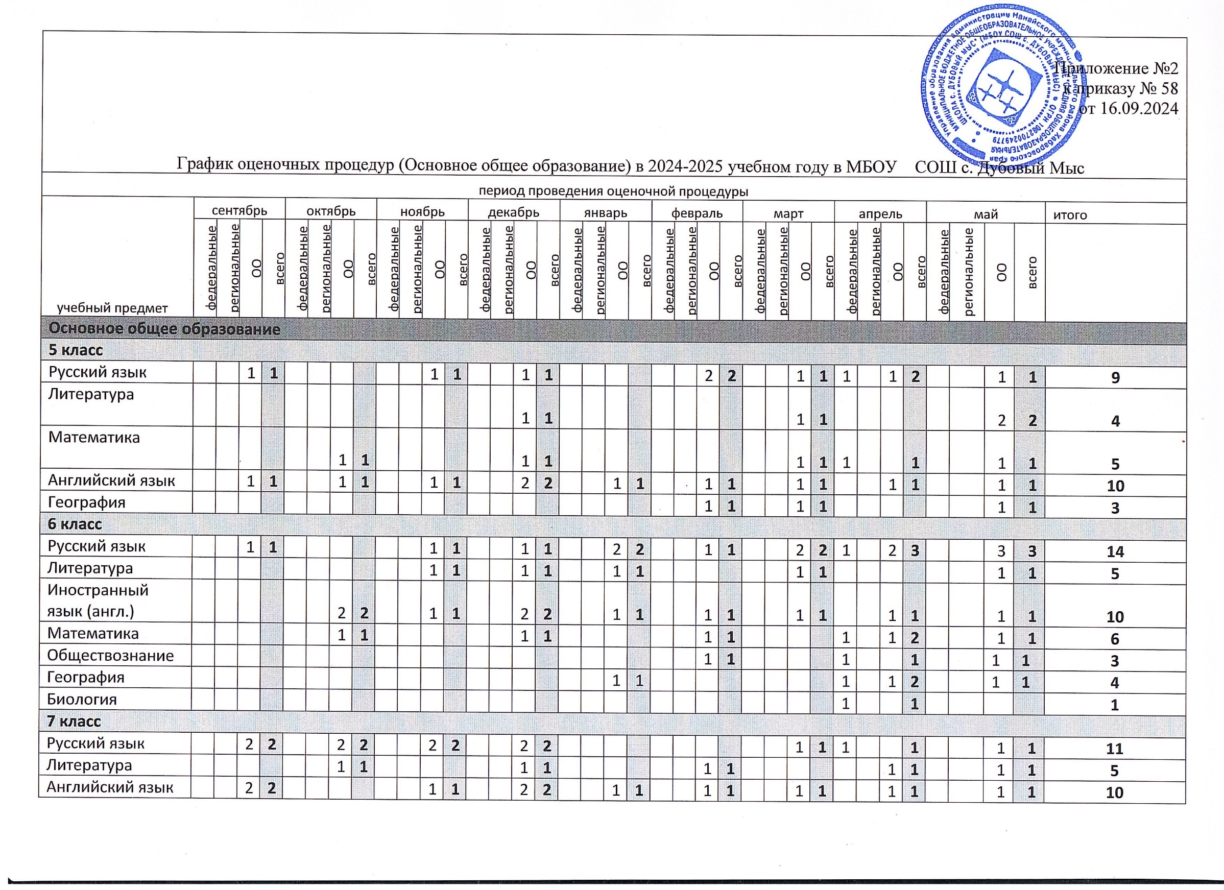

|  |  |  |  |  |  |  |  |  |  |  |  |  |  |  |  |  |  |  |  |  |  |  |  |  |  |  |  |  |  |  |  |  |  |  |  |  |  |
| --- | --- | --- | --- | --- | --- | --- | --- | --- | --- | --- | --- | --- | --- | --- | --- | --- | --- | --- | --- | --- | --- | --- | --- | --- | --- | --- | --- | --- | --- | --- | --- | --- | --- | --- | --- | --- | --- |
| Алгебра |  |  | 1 | **1** |  |  | 1 | **1** |  |  |  |  |  |  | 1 | **1** |  |  |  |  |  |  |  |  |  |  | 1 | **1** | 1 |  |  | **1** |  |  | 1 | **1** | **6** |
| Геометрия |  |  |  |  |  |  |  |  |  |  |  |  |  |  | 1 | **1** |  |  |  |  |  |  |  |  |  |  |  |  |  |  |  |  |  |  | 1 | **1** | **2** |
| История |  |  |  |  |  |  |  |  |  |  |  |  |  |  |  |  |  |  |  |  |  |  |  |  |  |  |  |  | 1 |  |  | **1** |  |  |  |  | **1** |
| Обществознание |  |  |  |  |  |  |  |  |  |  | 1 | **1** |  |  |  |  |  |  |  |  |  |  |  |  |  |  |  |  | 1 |  | 1 | **2** |  |  |  |  | **3** |
| География |  |  |  |  |  |  |  |  |  |  |  |  |  |  |  |  |  |  |  |  |  |  | 1 | **1** |  |  |  |  | 1 |  |  | **1** |  |  | 2 | **2** | **4** |
| Биология |  |  |  |  |  |  |  |  |  |  |  |  |  |  |  |  |  |  |  |  |  |  |  |  |  |  |  |  | 1 |  |  | **1** |  |  |  |  | **1** |
| **8 класс** | | | | | | | | | | | | | | | | | | | | | | | | | | | | | | | | | | | | | |
| Русский язык |  |  | 2 | **2** |  |  | 1 | **1** |  |  |  |  |  |  | 1 | **1** |  |  | 1 | **1** |  |  | 1 | **1** |  |  | 1 | **1** | 1 |  | 1 | **2** |  |  | 1 | **1** | **10** |
| Литература |  |  |  |  |  |  | 1 | **1** |  |  | 1 | **1** |  |  | 1 | **1** |  |  |  |  |  |  | 1 | **1** |  |  | 1 | **1** |  |  | 1 | **1** |  |  | 1 | **1** | **7** |
| Иностранный язык (англ.) |  |  | 1 | **1** |  |  | 1 | **1** |  |  | 1 | **1** |  |  | 1 | **1** |  |  | 1 | **1** |  |  | 1 | **1** |  |  | 2 | **2** |  |  | 1 | **1** |  |  | 1 | **1** | **10** |
| Алгебра |  |  | 1 | **1** |  |  | 1 | **1** |  |  | 1 | **1** |  |  | 1 | **1** |  |  | 1 | **1** |  |  | 1 | **1** |  |  | 1 | **1** | 1 |  | 1 | **2** |  |  | 1 | **1** | **10** |
| Геометрия |  |  |  |  |  |  | 1 | **1** |  |  |  |  |  |  | 1 | **1** |  |  |  |  |  |  | 1 | **1** |  |  | 1 | **1** |  |  |  |  |  |  | 1 | **1** | **5** |
| История |  |  |  |  |  |  |  |  |  |  |  |  |  |  |  |  |  |  |  |  |  |  |  |  |  |  |  |  | 1 |  |  | **1** |  |  |  |  | **1** |
| Обществознание |  |  |  |  |  |  |  |  |  |  |  |  |  |  |  |  |  |  |  |  |  |  | 1 | **1** |  |  |  |  | 1 |  |  | **1** |  |  | 1 | **1** | **3** |
| География |  |  |  |  |  |  |  |  |  |  |  |  |  |  |  |  |  |  |  |  |  |  | 1 | **1** |  |  |  |  | 1 |  |  | **1** |  |  | 1 | **1** | **3** |
| Биология |  |  |  |  |  |  |  |  |  |  |  |  |  |  |  |  |  |  |  |  |  |  |  |  |  |  |  |  | 1 |  |  | **1** |  |  |  |  | **1** |
| Физика |  |  |  |  |  |  |  |  |  |  |  |  |  |  |  |  |  |  |  |  |  |  |  |  |  |  |  |  | 1 |  |  | **1** |  |  |  |  | **1** |
| Химия |  |  |  |  |  |  |  |  |  |  | 1 | **1** |  |  | 1 | **1** |  |  |  |  |  |  |  |  |  |  | 1 | **1** | 1 |  |  | **1** |  |  | 1 | **1** | **5** |
| **9 класс** | | | | | | | | | | | | | | | | | | | | | | | | | | | | | | | | | | | | | |
| Русский язык |  |  | 2 | **2** |  |  |  |  |  |  | 1 | **1** |  |  | 1 | **1** |  |  |  |  |  |  | 1 | **1** | 1 |  | 1 | **2** |  |  | 1 | **1** |  |  | 1 | **1** | **9** |
| Литература |  |  | 1 | **1** |  |  |  |  |  |  | 1 | **1** |  |  | 1 | **1** |  |  | 1 | **1** |  |  | 1 | **1** |  |  | 1 | **1** |  |  |  |  |  |  | 2 | **2** | **8** |
| Алгебра |  |  |  |  |  |  |  |  |  |  |  |  |  |  | 1 | **1** |  |  |  |  |  |  |  |  | 1 |  |  | **1** |  |  |  |  |  |  | 1 | **1** | **3** |
| Геометрия |  |  | 1 | **1** |  |  |  |  |  |  | 1 | **1** |  |  |  |  |  |  |  |  |  |  | 1 | **1** |  |  |  |  |  |  | 1 | **1** |  |  |  |  | **4** |
| История |  |  |  |  |  |  |  |  |  |  |  |  |  |  |  |  |  |  |  |  |  |  |  |  | 1 |  |  | **1** |  |  |  |  |  |  |  |  | **1** |
| Обществознание |  |  |  |  |  |  |  |  |  |  |  |  |  |  | 1 | **1** |  |  |  |  |  |  |  |  | 1 |  |  | **1** |  |  |  |  |  |  | 1 | **1** | **3** |
| География |  |  |  |  |  |  | 1 | **1** |  |  |  |  |  |  | 1 | **1** |  |  |  |  |  |  | 1 | **1** | 1 |  |  | **1** |  |  | 1 | **1** |  |  |  |  | **5** |
| Биология |  |  |  |  |  |  |  |  |  |  |  |  |  |  |  |  |  |  |  |  |  |  |  |  | 1 |  |  | **1** |  |  |  |  |  |  |  |  | **1** |
| Химия |  |  | 1 | **1** |  |  |  |  |  |  | 1 | **1** |  |  |  |  |  |  |  |  |  |  | 1 | **1** |  |  |  |  |  |  | 1 | **1** |  |  |  |  | **4** |